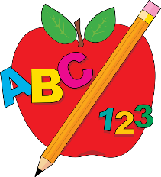
FIRST GRADE SUPPLY LIST

Dear Parents/Guardians,

We hope that everyone had a wonderful summer! We are looking forward to meeting your child in September! First grade is filled with lots of learning, growing, and maturing. We are excited for a fun year ahead!

Listed below are the supplies that your child needs for first grade. Students should bring these supplies on the first day of school.

***We will supply a pencil box for each student, so please do not send one in.***

- PENCILS (NO PENS)
- 1 Box of (8, 16, or 24) count crayons
- 2 Large glue sticks
- 1 Pair of blunt tip scissors
- 2 BLACK dry erase markers
- An emergency change of clothing in a plastic bag, labeled with your child’s name

The following items are also needed for our classrooms. If you can donate any of these extra items to your child’s classroom, it would be greatly appreciated!

- BLACK dry erase markers
- 3 Boxes of facial tissues
- Extra crayons
- Extra glue sticks

We thank you in advance for your contribution. Enjoy the rest of your summer!

Sincerely,
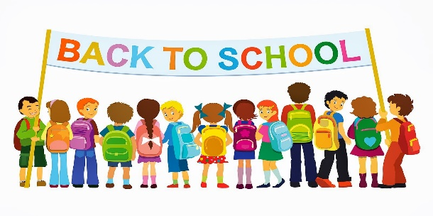
Smithville First Grade Teachers

