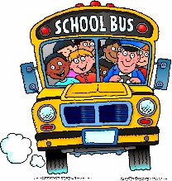

Dear Parents of 2019-2020 First Graders,
The teachers in the First Grade Unit are looking forward to meeting you and your first grader in September! Please see the list of school supplies below that are suggested to send in for the next school year, if it is financially within your budget. Please send them in with your child on the first day of school in September. We thank you in advance for any contribution you are able to make.
- 6 blue or black THIN POINT/low odor ONLY dry erasers markers (preferably Bic or EXPO as the others tend to leave permanent marks on boards)
- 6 boxes of tissues
- 1 marble notebook
- 1 box of 16-24 count crayons
- 2 two-pocket folders, durable or laminated preferred
- 10 glue sticks
- 1 dozen THICK PRIMARY pencils only
- 1 pair blunt tip scissors
- A set of comfortable child size headphones or earbuds
- An emergency change of clothing
In the meantime, we hope you have a fun-filled, safe summer!
Smithville First Grade Teachers

